**Noise**

**4110056030 資工三 鄭詠謙**

* **Code**

撒上雜訊胡椒鹽

Pa 設為1/4

Pb 設為1/3

Pa = 1/4  # 雜訊的黑色點機率

Pb = 1/3  # 雜訊的白色點機率

def addImpulseNoise(img):

    # Impulse noise

    for i in range(border, img.shape[0] - border):

        for j in range(border, img.shape[1] - border):

            x = random.random()

            if x < Pa:

                img[i, j] = 0

            elif x < Pa + Pb:

                img[i, j] = 255

加入NCHU跟CSE的黑白字

noisy_image = srcImg.copy()

    addImpulseNoise(noisy_image)

draw_text(noisy_image, 'CSE', (10, 30), (0, 0, 0),

font_scale=1.0)

    draw_text(noisy_image, 'NCHU', (600, 30), (255, 255, 255),

font_scale=1.0)

輸出(show出)Median Filter及Adaptive Median Filter後的結果並計算PSNR

def filter(src, dst, type):

    for i in range(border, dst.shape[0] - border):

        for j in range(border, dst.shape[1] - border):

            if type == FilterType.AdaptiveMedian:

                dst[i, j] = adaptive_median_filter(src, i, j)

            else:

                mask = []

                for u in range(i - border, i + border + 1):

                    for v in range(j - border, j + border + 1):

                        mask.append(src[u, v])

                dst[i, j] = bubble_sort(mask, type)

def bubble_sort(arr, type):

    arr.sort()

    if type == FilterType.Median:

        return arr[len(arr) // 2]

def adaptive_median_filter(img, i, j, max_window_size=7):

    window_size = 3

    while window_size <= max_window_size:

        border = window_size // 2

        mask = []

        for u in range(i - border, i + border + 1):

            for v in range(j - border, j + border + 1):

                if 0 <= u < img.shape[0] and 0 <= v < img.shape[1]:

                    mask.append(img[u, v])

        mask.sort()

        Z_min = mask[0]

        Z_max = mask[-1]

        Z_med = mask[len(mask) // 2]

        if Z_min < Z_med < Z_max:

            Z_xy = img[i, j]

            if Z_min < Z_xy < Z_max:

                return Z_xy

            else:

                return Z_med

        else:

            window_size += 2

    return img[i, j]

def psnr(original, filtered):

    mse = np.mean((original - filtered) ** 2)

    if mse == 0:

        return float('inf')

    max_pixel = 255.0

    return 20 * math.log10(max_pixel / math.sqrt(mse))

完整程式碼:

import cv2

import numpy as np

import random

import math

class FilterType:

    Median, AdaptiveMedian = range(2)

Source_Image_Path = "input.jpg"

window_name_1 = "Original Image"

window_name_2 = "Source Image with Impulse Noise"

window_name_3 = "Median Filter"

window_name_4 = "Adaptive Median Filter"

Pa = 1/4  # 椒鹽雜訊的黑色點概率

Pb = 1/3  # 椒鹽雜訊的白色點概率

mask_size = 7

border = (mask_size - 1) // 2

mask_element = mask_size * mask_size

def addImpulseNoise(img):

    # Impulse noise

    for i in range(border, img.shape[0] - border):

        for j in range(border, img.shape[1] - border):

            x = random.random()

            if x < Pa:

                img[i, j] = 0

            elif x < Pa + Pb:

                img[i, j] = 255

def draw_text(img, text, position, color, font_scale):

    font = cv2.FONT_HERSHEY_SIMPLEX

    thickness = 1

    cv2.putText(img, text, position, font, font_scale, color, thickness, cv2.LINE_AA)

def filter(src, dst, type):

    for i in range(border, dst.shape[0] - border):

        for j in range(border, dst.shape[1] - border):

            if type == FilterType.AdaptiveMedian:

                dst[i, j] = adaptive_median_filter(src, i, j)

            else:

                mask = []

                for u in range(i - border, i + border + 1):

                    for v in range(j - border, j + border + 1):

                        mask.append(src[u, v])

                dst[i, j] = bubble_sort(mask, type)

def bubble_sort(arr, type):

    arr.sort()

    if type == FilterType.Median:

        return arr[len(arr) // 2]

def adaptive_median_filter(img, i, j, max_window_size=7):

    window_size = 3

    while window_size <= max_window_size:

        border = window_size // 2

        mask = []

        for u in range(i - border, i + border + 1):

            for v in range(j - border, j + border + 1):

                if 0 <= u < img.shape[0] and 0 <= v < img.shape[1]:

                    mask.append(img[u, v])

        mask.sort()

        Z_min = mask[0]

        Z_max = mask[-1]

        Z_med = mask[len(mask) // 2]

        if Z_min < Z_med < Z_max:

            Z_xy = img[i, j]

            if Z_min < Z_xy < Z_max:

                return Z_xy

            else:

                return Z_med

        else:

            window_size += 2

    return img[i, j]

def psnr(original, filtered):

    mse = np.mean((original - filtered) ** 2)

    if mse == 0:

        return float('inf')

    max_pixel = 255.0

    return 20 * math.log10(max_pixel / math.sqrt(mse))

def main():

    srcImg = cv2.imread(Source_Image_Path, cv2.IMREAD_UNCHANGED)

    if srcImg is None:

        print("Error")

        return -1

    cv2.namedWindow(window_name_1, cv2.WINDOW_AUTOSIZE)

    cv2.namedWindow(window_name_2, cv2.WINDOW_AUTOSIZE)

    cv2.namedWindow(window_name_3, cv2.WINDOW_AUTOSIZE)

    cv2.namedWindow(window_name_4, cv2.WINDOW_AUTOSIZE)

    original_image = srcImg.copy()

    # Convert to grayscale

    srcImg = cv2.cvtColor(srcImg, cv2.COLOR_BGR2GRAY)

    random.seed()

    result_median = np.zeros_like(srcImg)

    result_adaptive_median = np.zeros_like(srcImg)

    noisy_image = srcImg.copy()

    addImpulseNoise(noisy_image)

    # Draw text on the noisy image

    draw_text(noisy_image, 'CSE', (10, 30), (0, 0, 0), font_scale=1.0)

    draw_text(noisy_image, 'NCHU', (600, 30), (255, 255, 255), font_scale=1.0)

    cv2.imshow(window_name_1, original_image)  # Original Image

    cv2.imshow(window_name_2, noisy_image)  # Source Image with Impulse Noise

    filter(noisy_image, result_median, FilterType.Median)

    cv2.imshow(window_name_3, result_median)  # Median Filter

    filter(noisy_image, result_adaptive_median, FilterType.AdaptiveMedian)

    cv2.imshow(window_name_4, result_adaptive_median)  # Adaptive Median Filter

    psnr_median = psnr(srcImg, result_median)

    psnr_adaptive_median = psnr(srcImg, result_adaptive_median)

    print(f"PSNR(Median Filter): {psnr_median}")

    print(f"PSNR(Adaptive Median Filter): {psnr_adaptive_median}")

    cv2.waitKey(0)

    return 0

if __name__ == "__main__":

    main()

* **Result**

左上為原圖、右上為使用Impulse Noise

左下為Median Filter、右下為Adaptive Median Filter

Median Filter的Mask分別使用3x3、5x5、7x7，Adaptive Median Filter則不須手動調整mask

Mask 3x3:

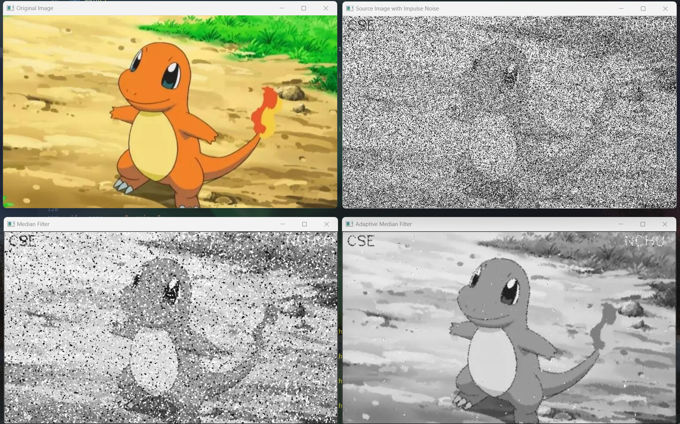

Mask 5x5:

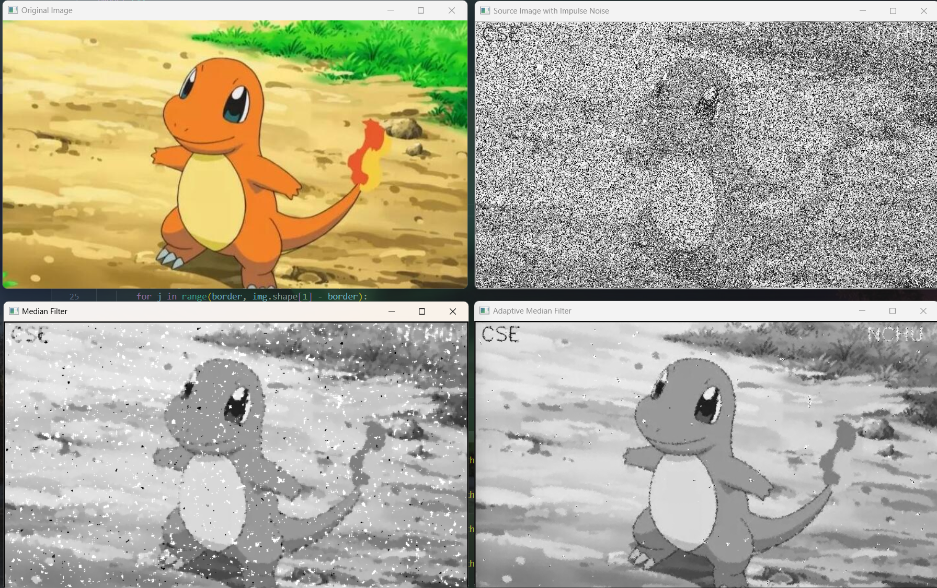

Mask 7x7:

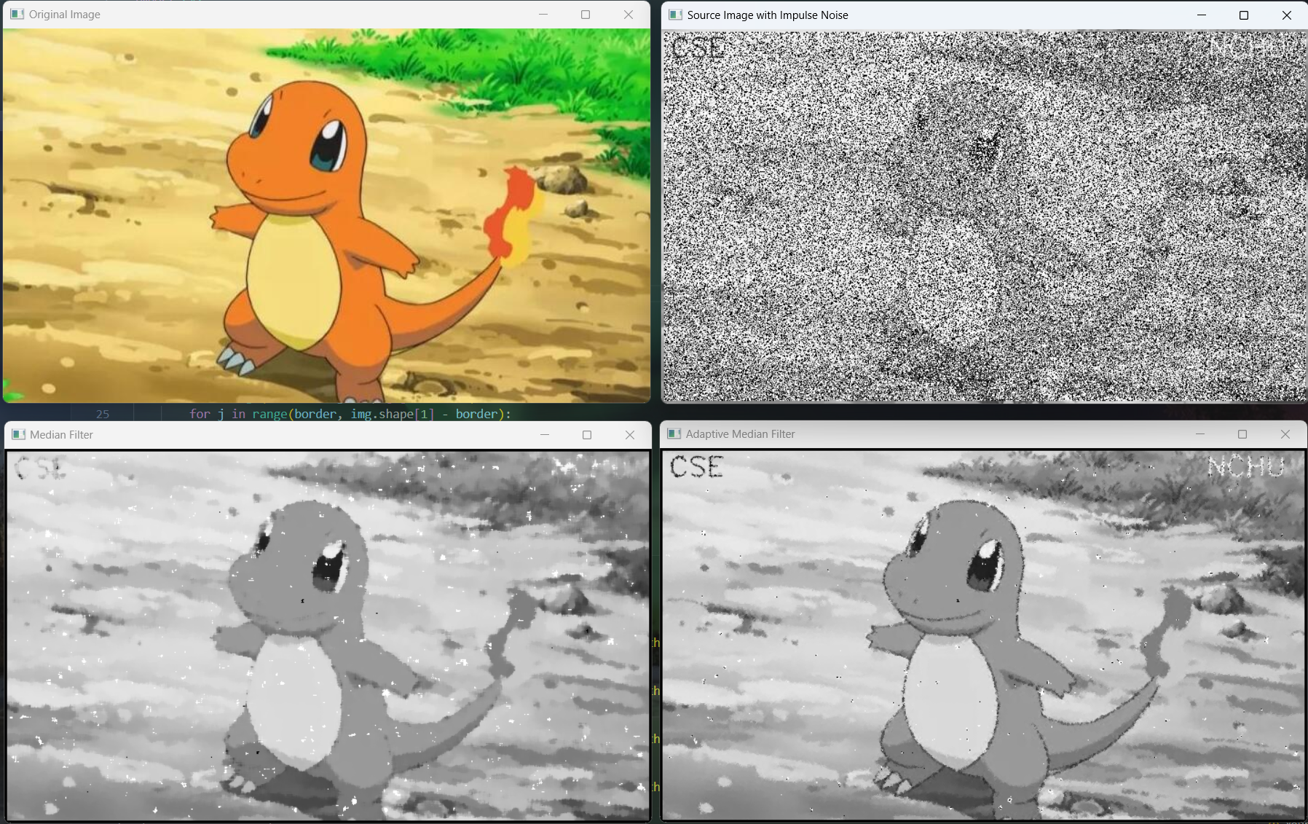

Impulse Noise後可以看到以下的樣子:

機率設定為Z=0: 1/4 、Z=255: 1/3

在左上角印上黑色的CSE、右上角印上白色的NCHU

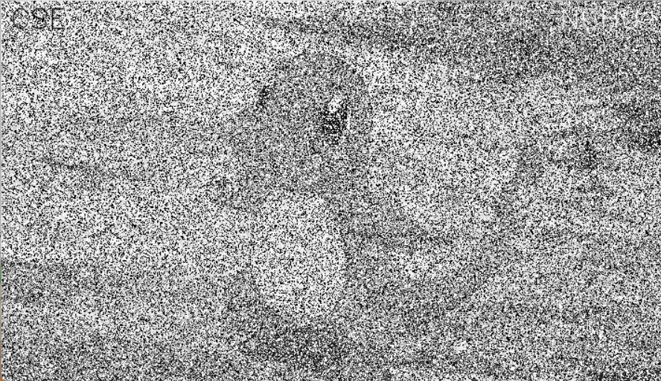

Mask使用3x3之結果

Median Filter:

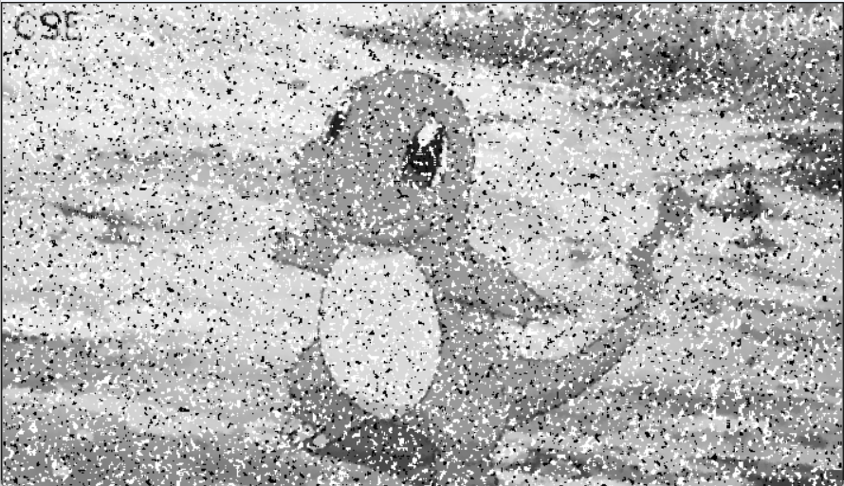

Adaptive Median Filter:

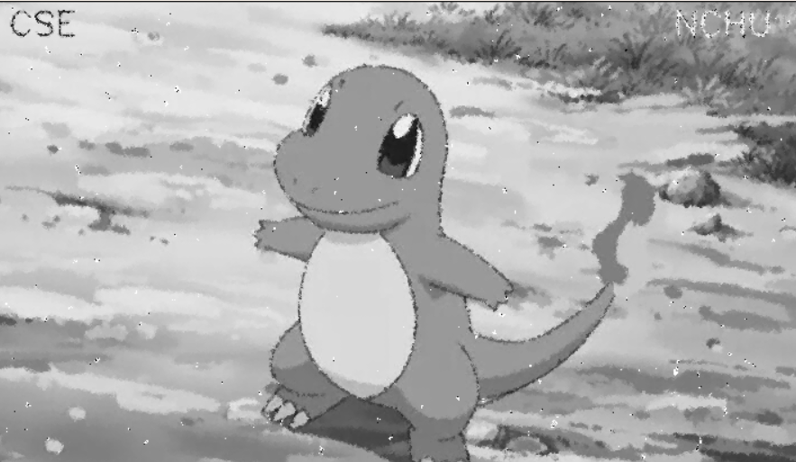



Mask使用5x5之結果

Median Filter:

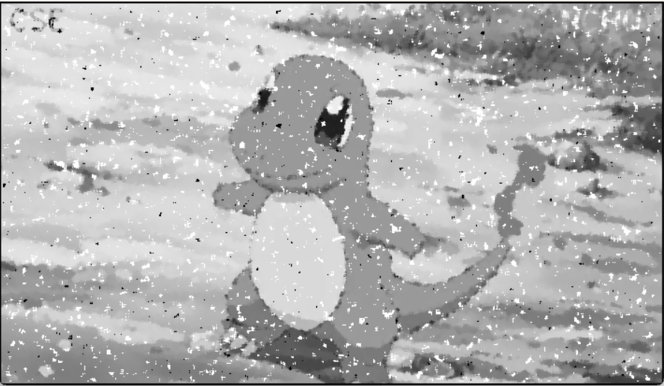

Adaptive Median Filter:

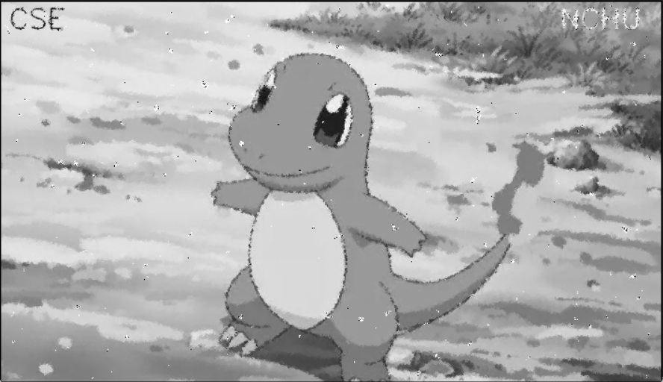



Mask使用7x7之結果

Median Filter:

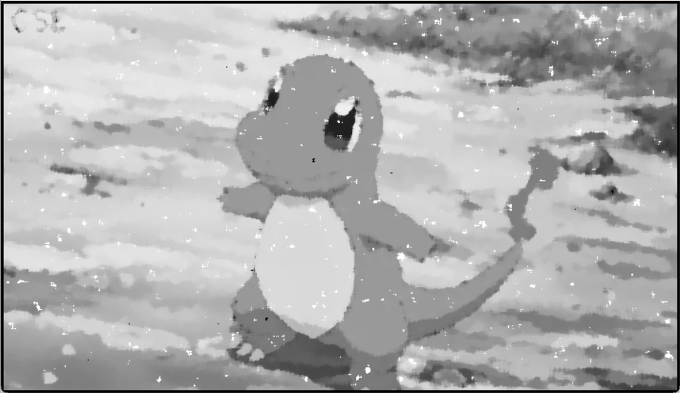

Adaptive Median Filter:

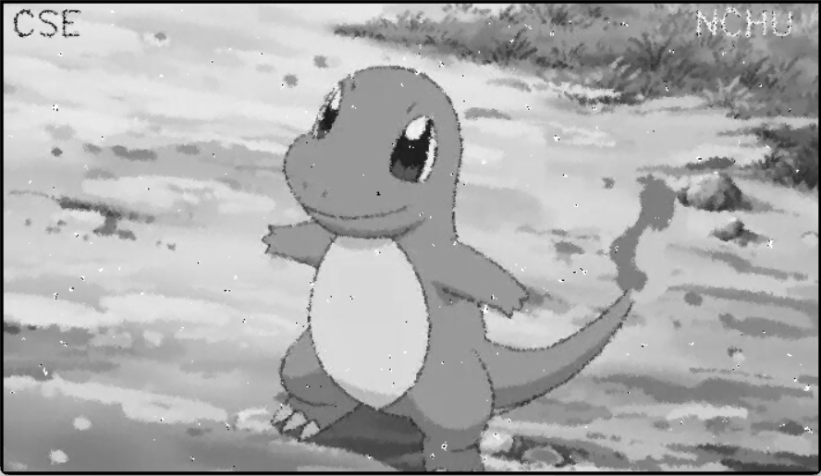



* **Discussion**
  + Mask大小會影響濾波器的效果，以Median Filter來看，mask 7x7的去除雜訊效果似乎最好，但其實圖中的細節也被模糊掉得更嚴重了。

Mask**越大**則更多的鄰近訊息被考慮進來，可以更好地去除圖像中的Noise，但同時也可能使圖像的細節部分變得模糊。

****3x3

****5x5

7x7

* + 比較Median Filter & Adaptive Median Filter的方法為計算PSNR，由於手動調整mask大小會有模糊或去噪效果不佳的情況。因此需要自適應中值濾波器。中值濾波器是**將周邊的資料抓進來做排序，然後用排序後中間的那個值做為輸出。**從前述Filter的PSNR值可以看出自適應中值濾波器總是優於中值濾波器。自適應中值濾波器是首先根據初始mask大小進行濾波，然後根據結果來決定是否需要擴大mask。自適應中值濾波器適用於處理具有不同尺度和強度的雜訊的影像，並且對於保留細節部分比較好。

例如下圖如果使用7x7 mask會吃掉很多細節，雖然去噪效果比3x3好，但是圖片很模糊; 下下圖用自適應則可以減少細節被吃掉的問題。

Median Filter



Adaptive Median Filter

